**PROJECT 1:**

**Deploying a web server in Windows instance**

* Created a windows server instance with Public IP- 18.217.120.22

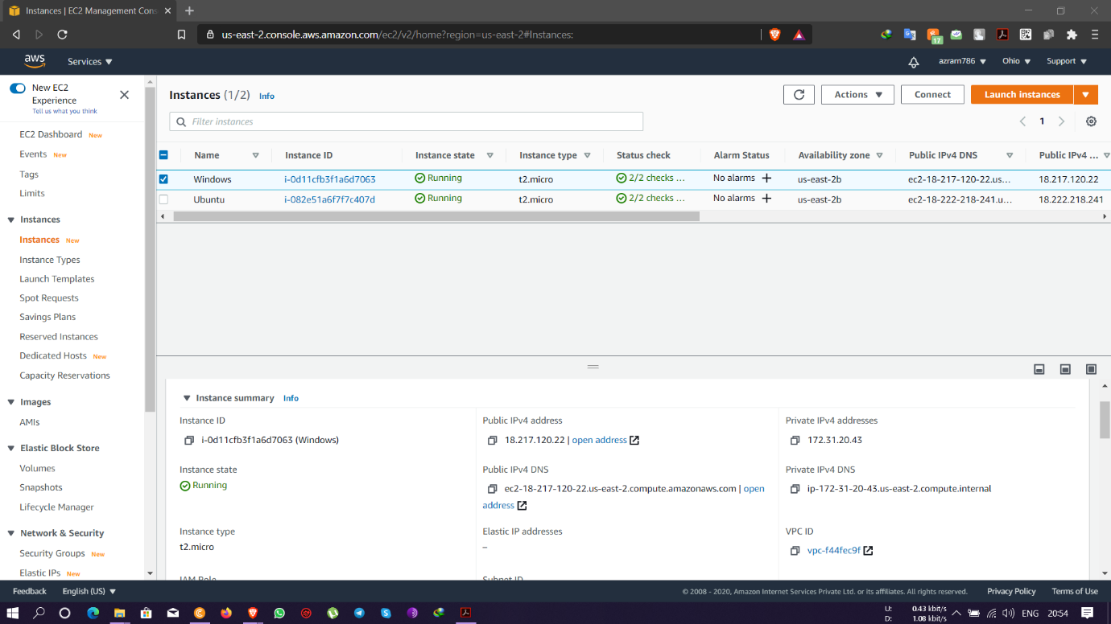

* Installation of IIS web server

Command used - Install-WindowsFeature -name Web-Server -IncludeManagementTools

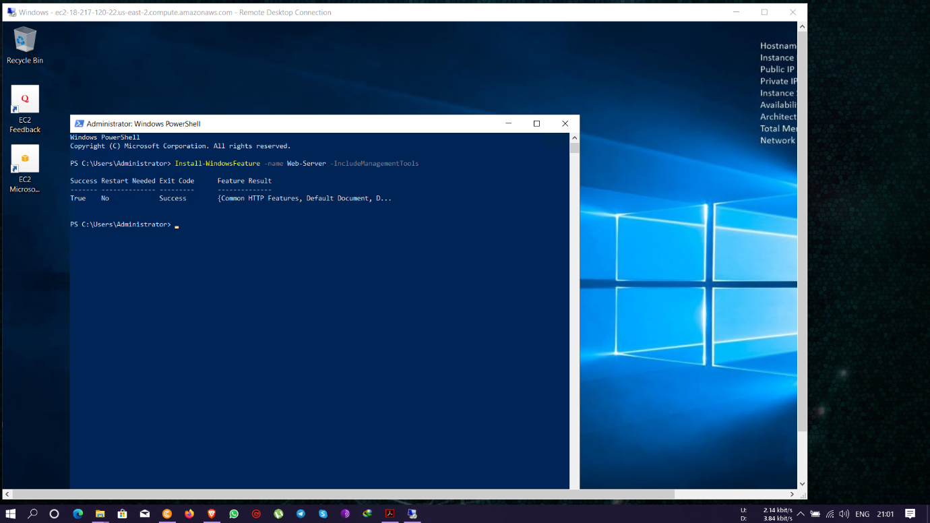

* Running IIS Windows server in Public IP- 18.217.120.22

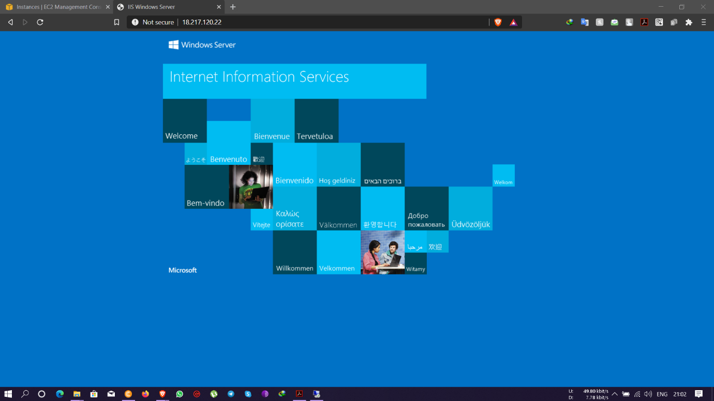

**PROJECT 2:**

**Deploying a web server in Linux (Ubuntu) Server instance**

* Created a linux (Ubuntu) server instance with public IP – 18.222.218.241

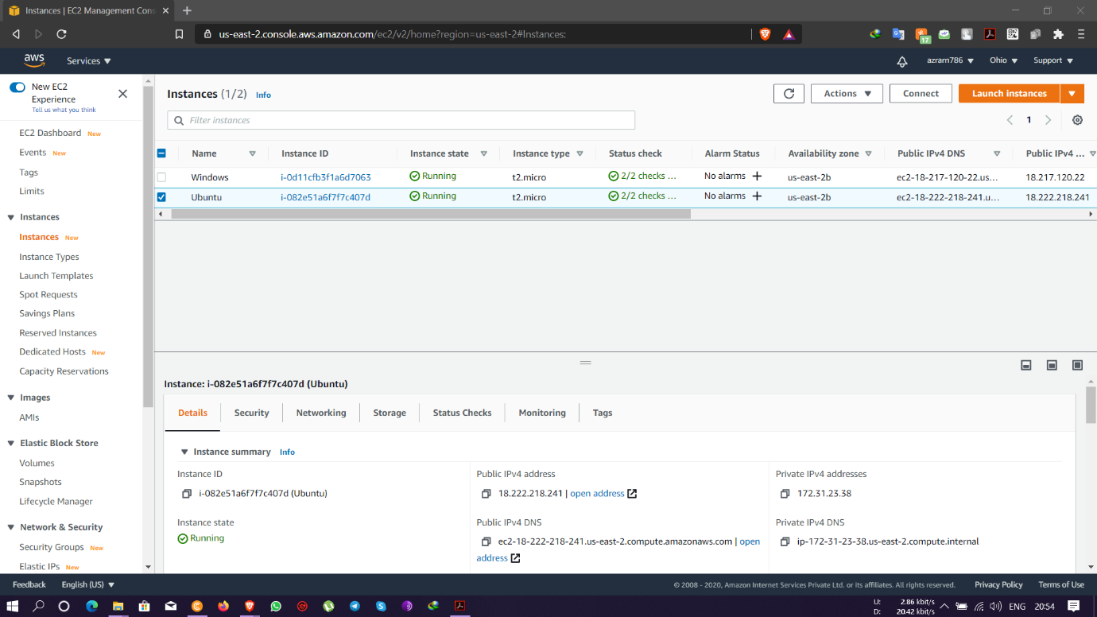

* Installation of ngnix web server

Commands used - sudo apt-get -y update & sudo apt-get -y install ngnix.

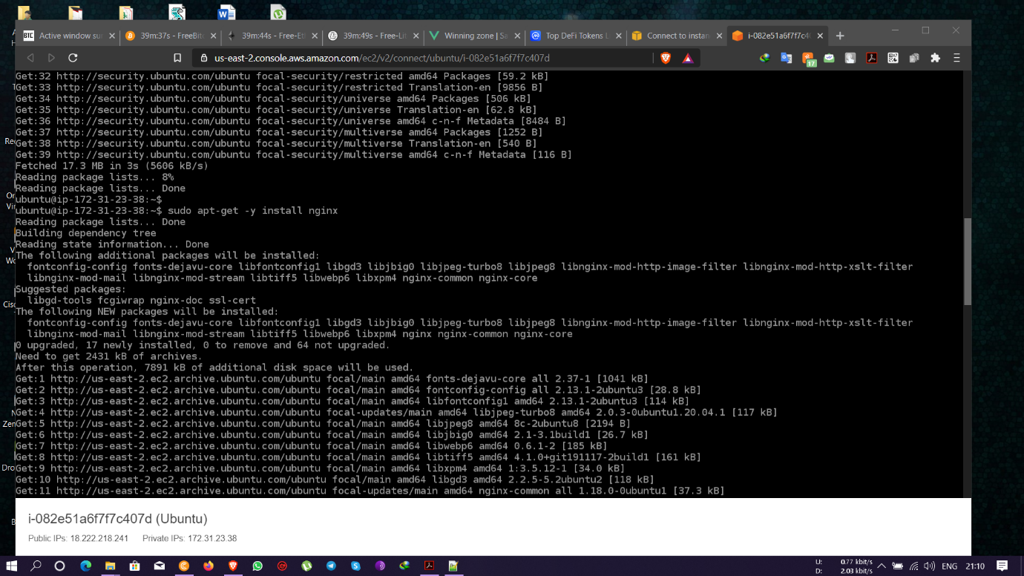

* Running ngnix server with public IP- 18.222.218.241

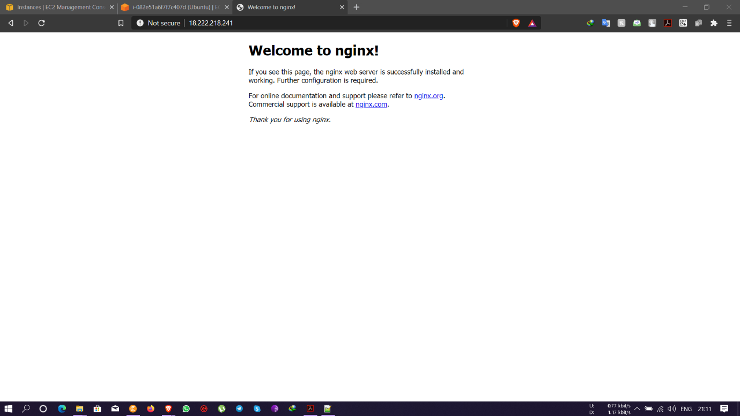

**PROJECT 3:**

**Working with volumes**

* Created a new EBS volume with name volume 1 of size 20GB and attached to the windows server instance.

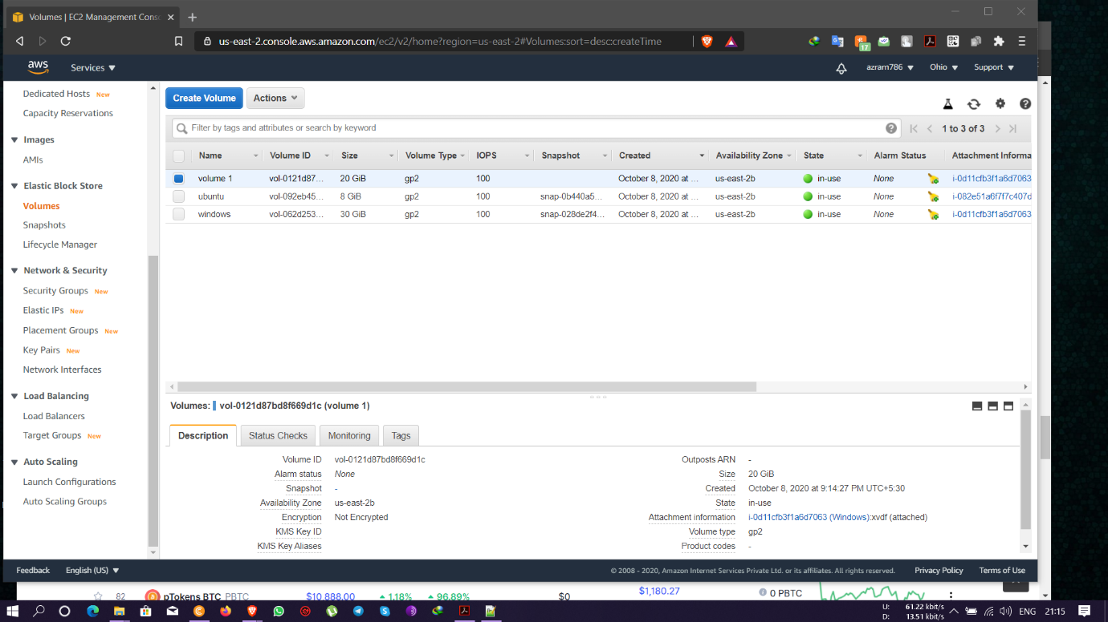

* New EBS volume being made online

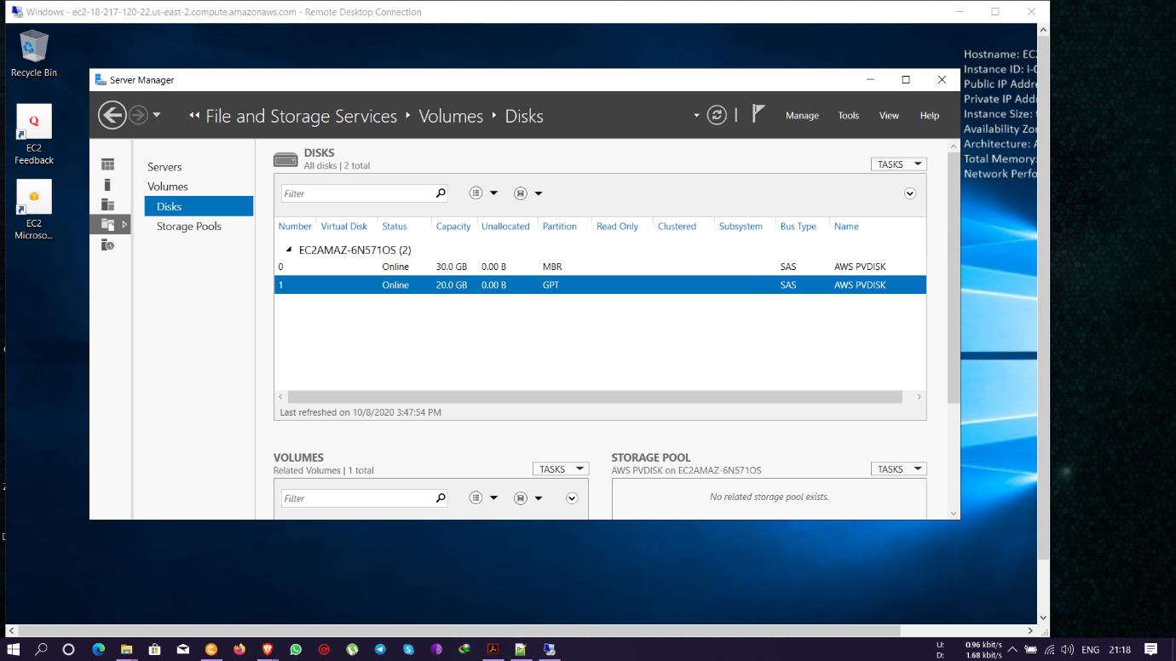

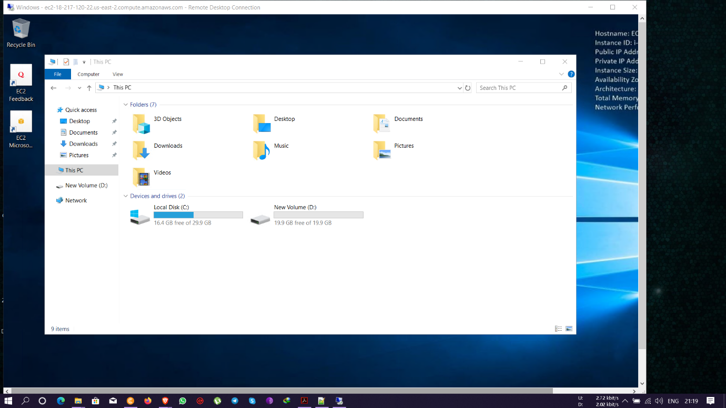

* Second EBS volume created and made online too.

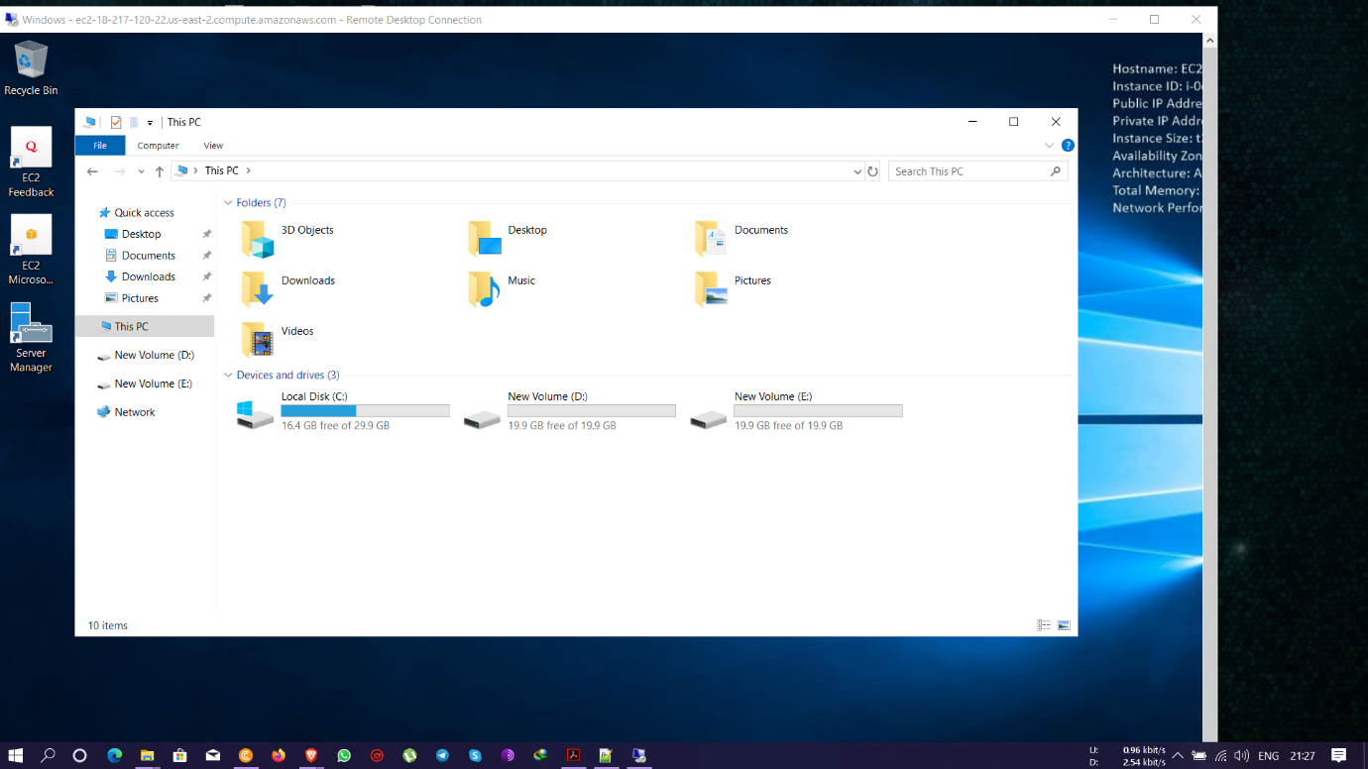

* Modifying the configuration for both the volumes created

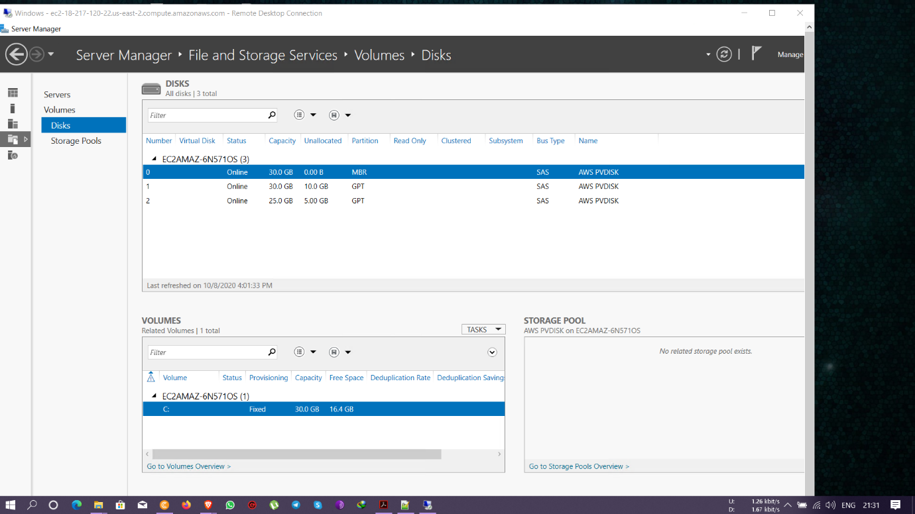

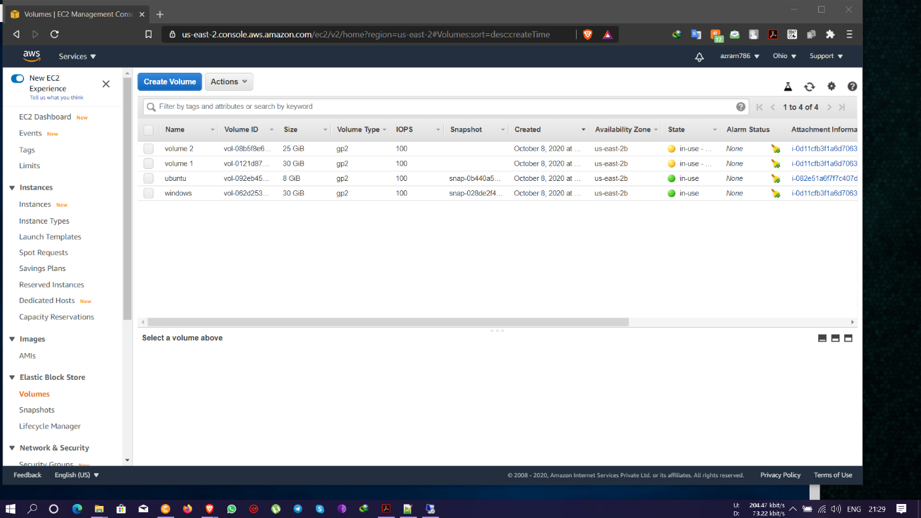

* Reallocated New storage size for both the volumes

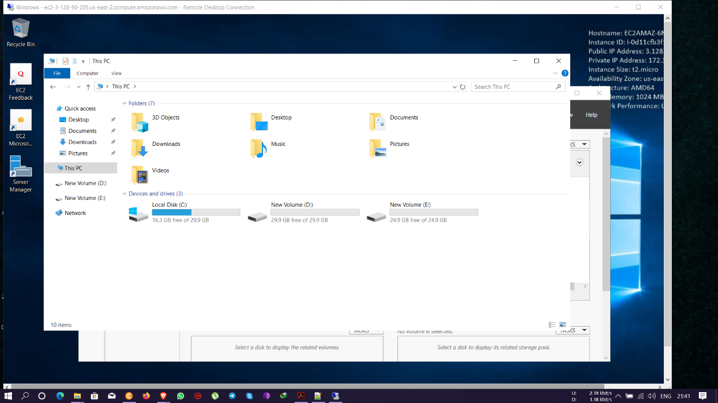

* Dethatching the Volume for the Windows Instance and making it available

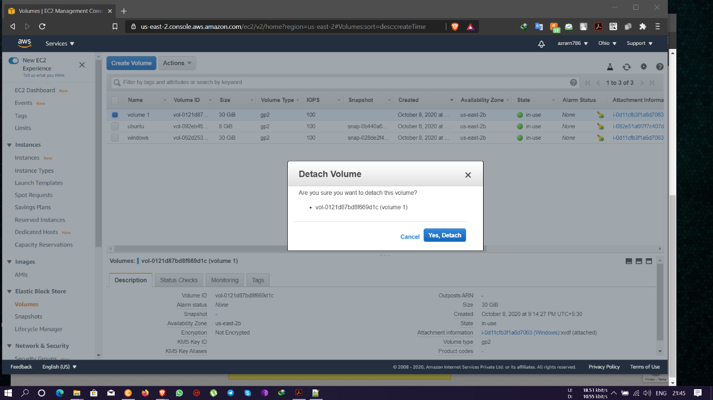

* Deleting the EBS volume permanently after dethatching it

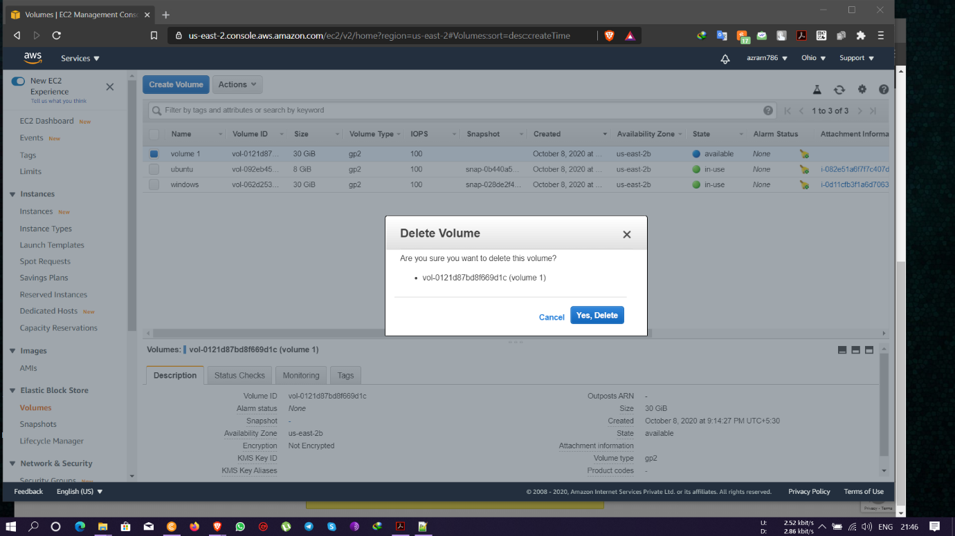

**PROJECT 4:**

**Working with Elastic IP's**

* Created a Linux instance with public IP – 18.219.167.227

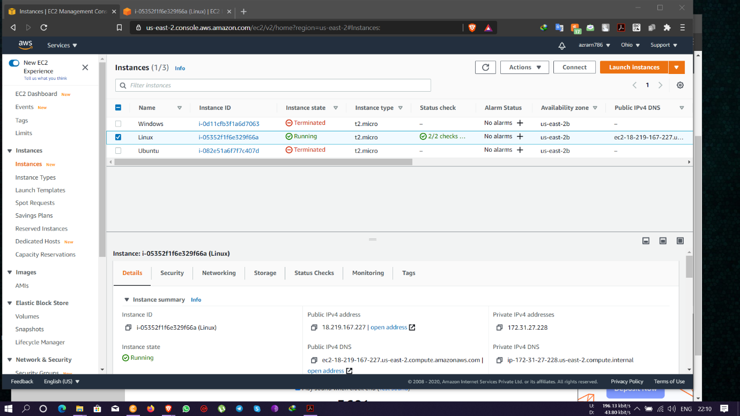

* Installing and running Apache Web service

Commands used-

For getting Super User Privileges- sudo -s.

For Updating- yum -y update.

For installing apache web sevices- yum install httpd, systemctl start httpd, systemctl enable httpd, systemctl status httpd.

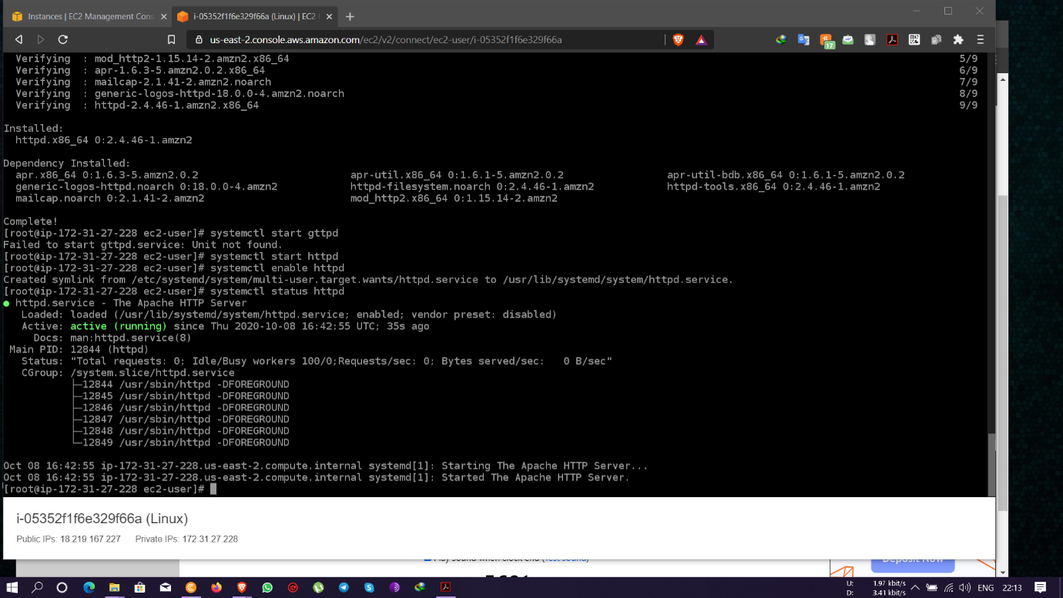

* Running Apache web service with Public IP- 18.219.167.227
* 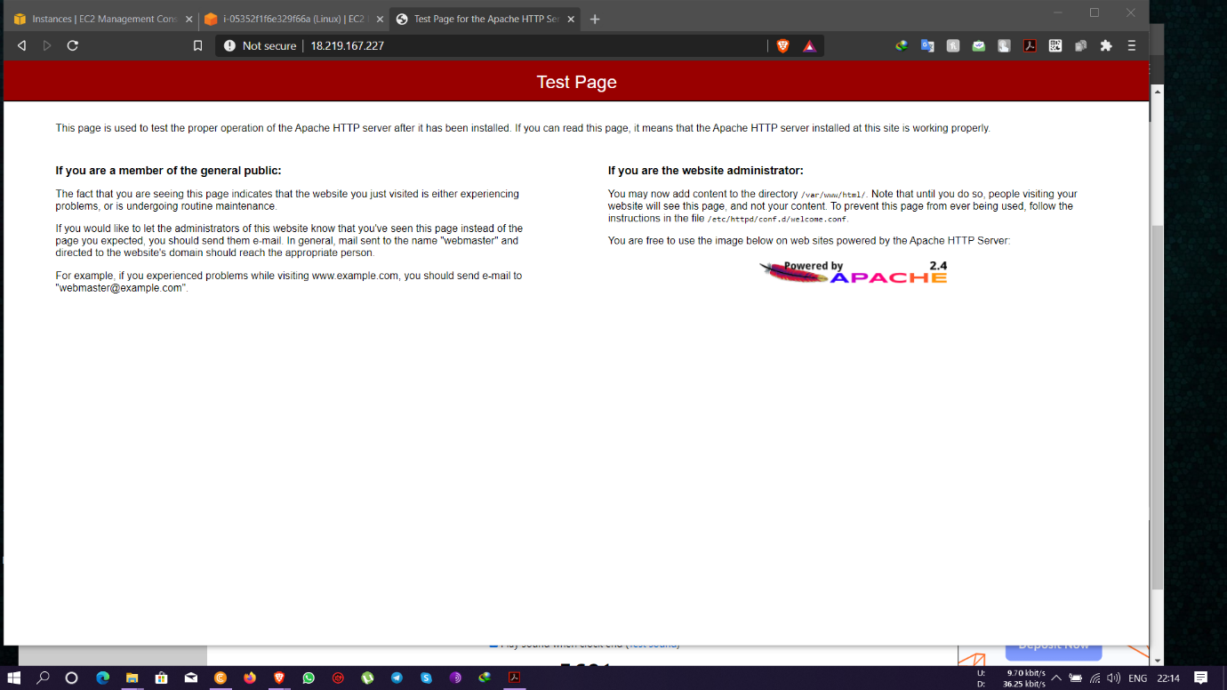
* Creating an Elastic IP address

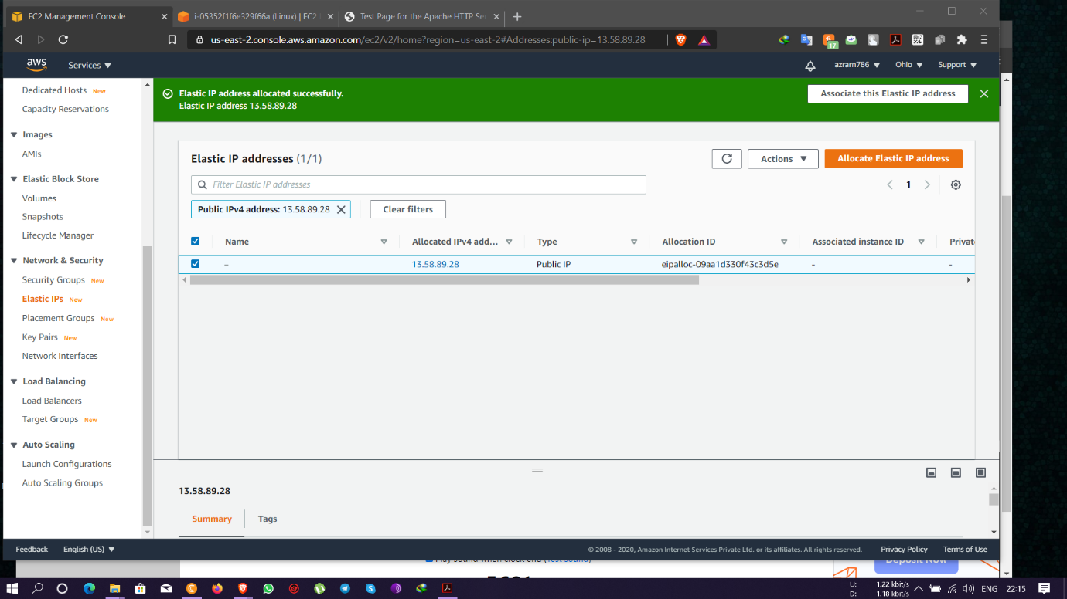

* Associating the Elastic IP address with the Linux Instance

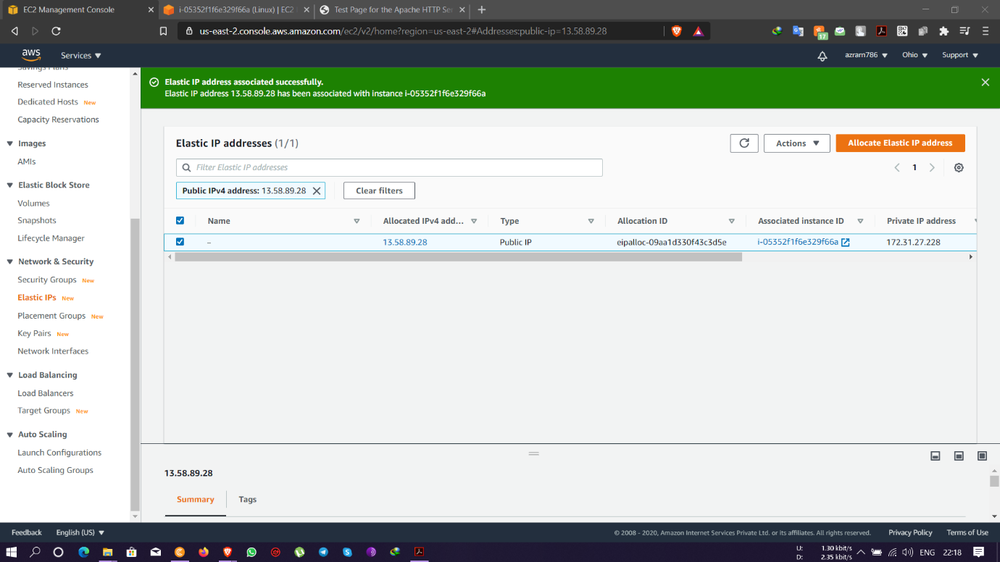

* Previous Public IP of Linux instance not reachable anymore for web services as it is associated with a new elastic IP address

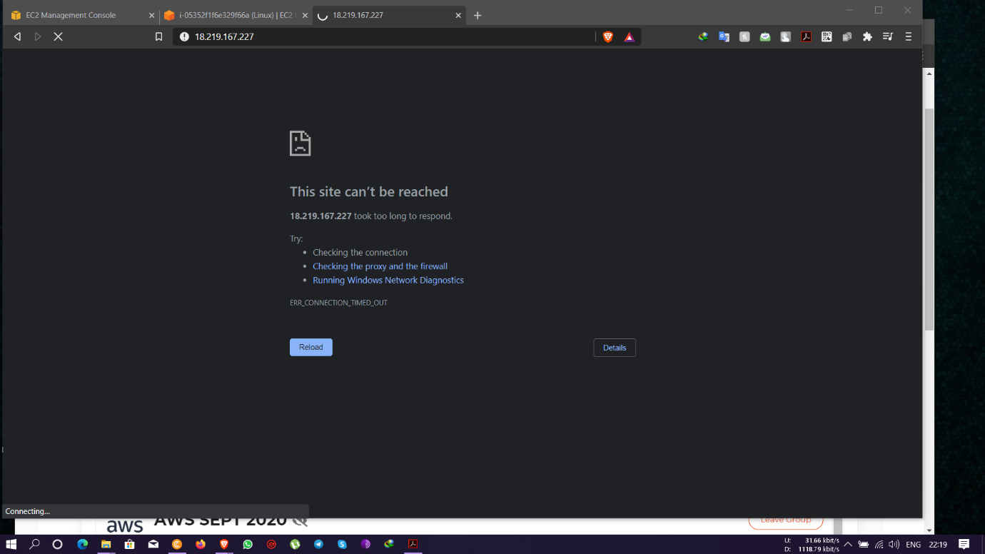

* Running Apache web service with new Public IP- 13.58.89.28 of Elastic IP

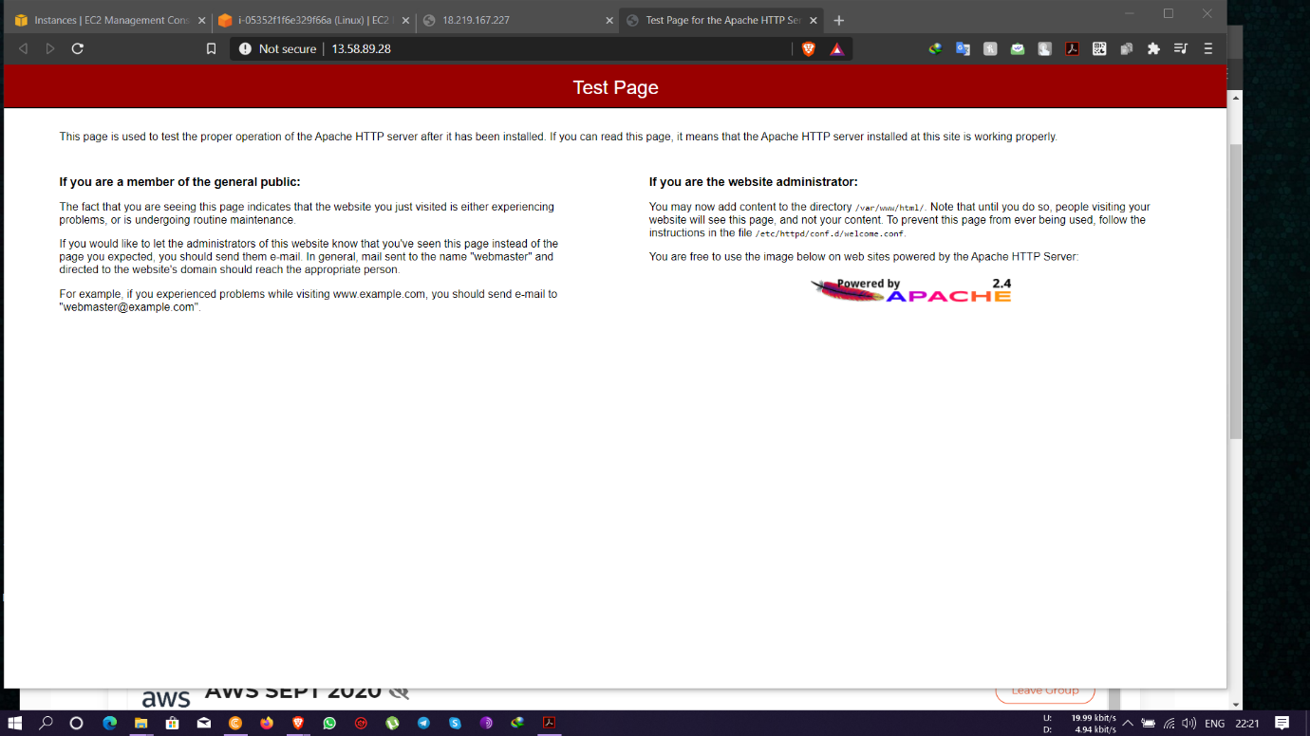

**PROJECT 5:**

**Working with S3**

* Created two new S3 buckets with global unique names 1. azhar786, 2. azrarn786

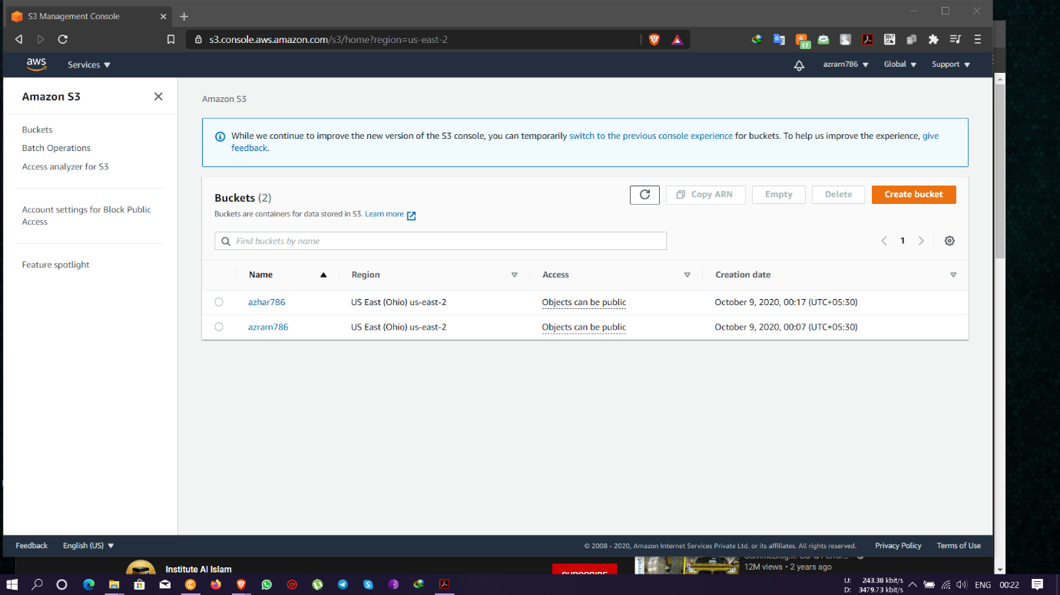

* Changing permission policies

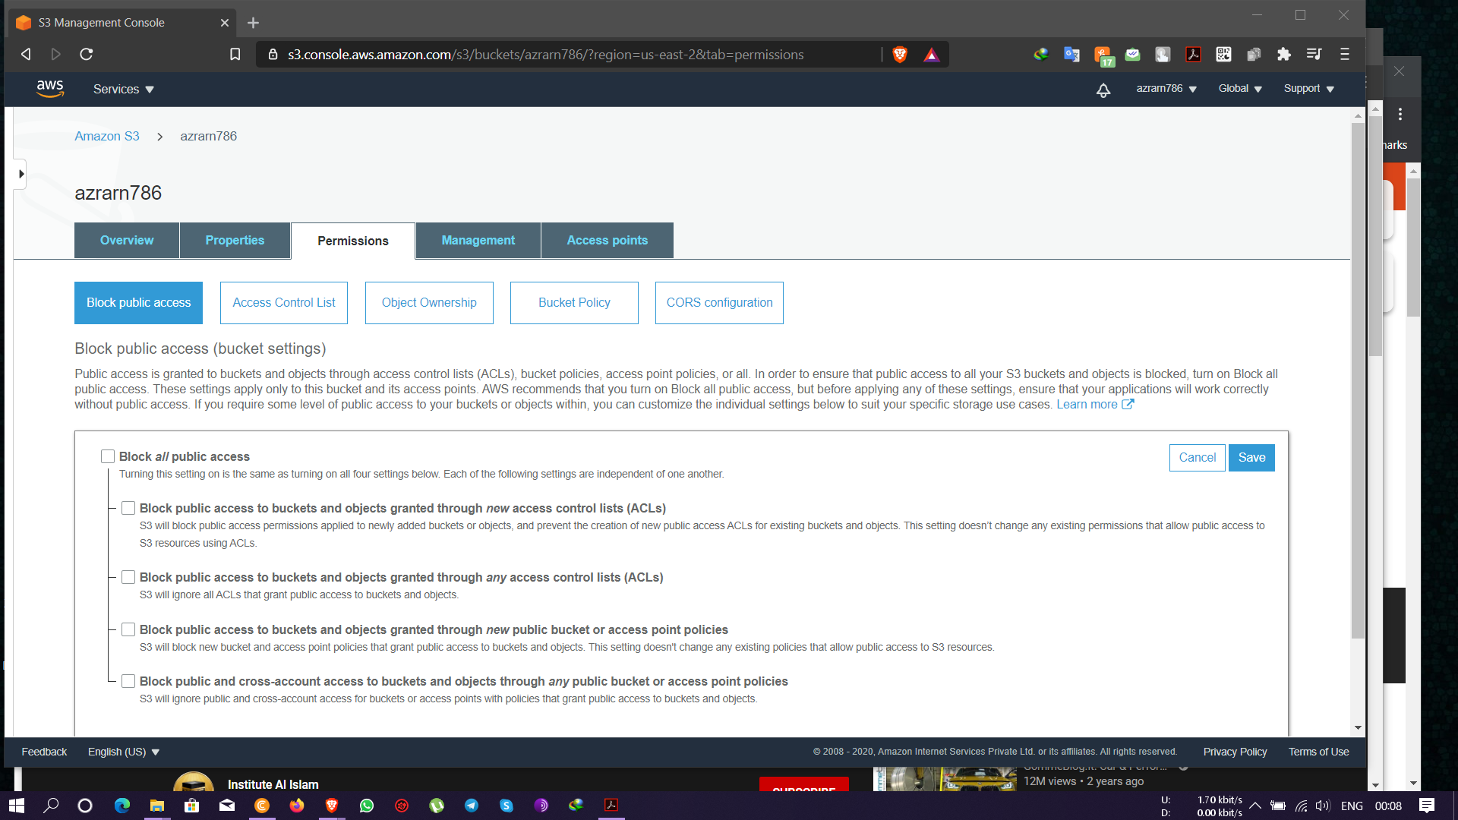

* Uploading index.txt and error.txt files for Static web hosting

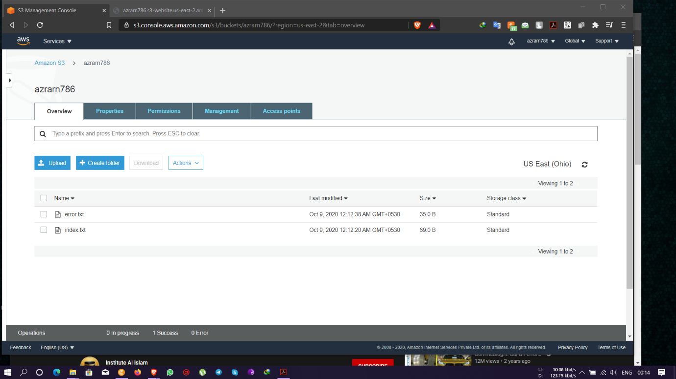

* The index.txt page live through AWS static web hosting

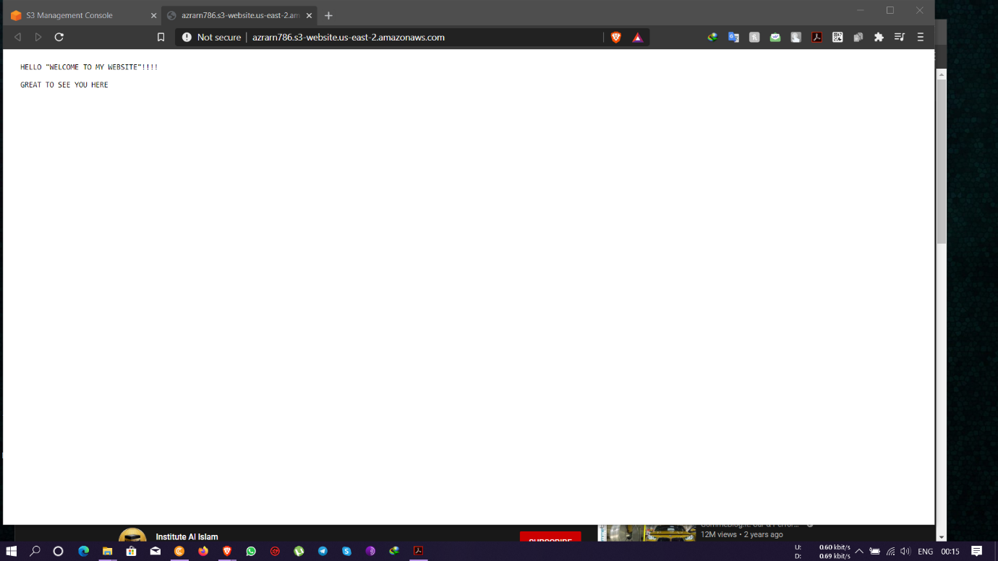

* The error.txt page displays live through AWS static web hosting when changes made to the web hosting address

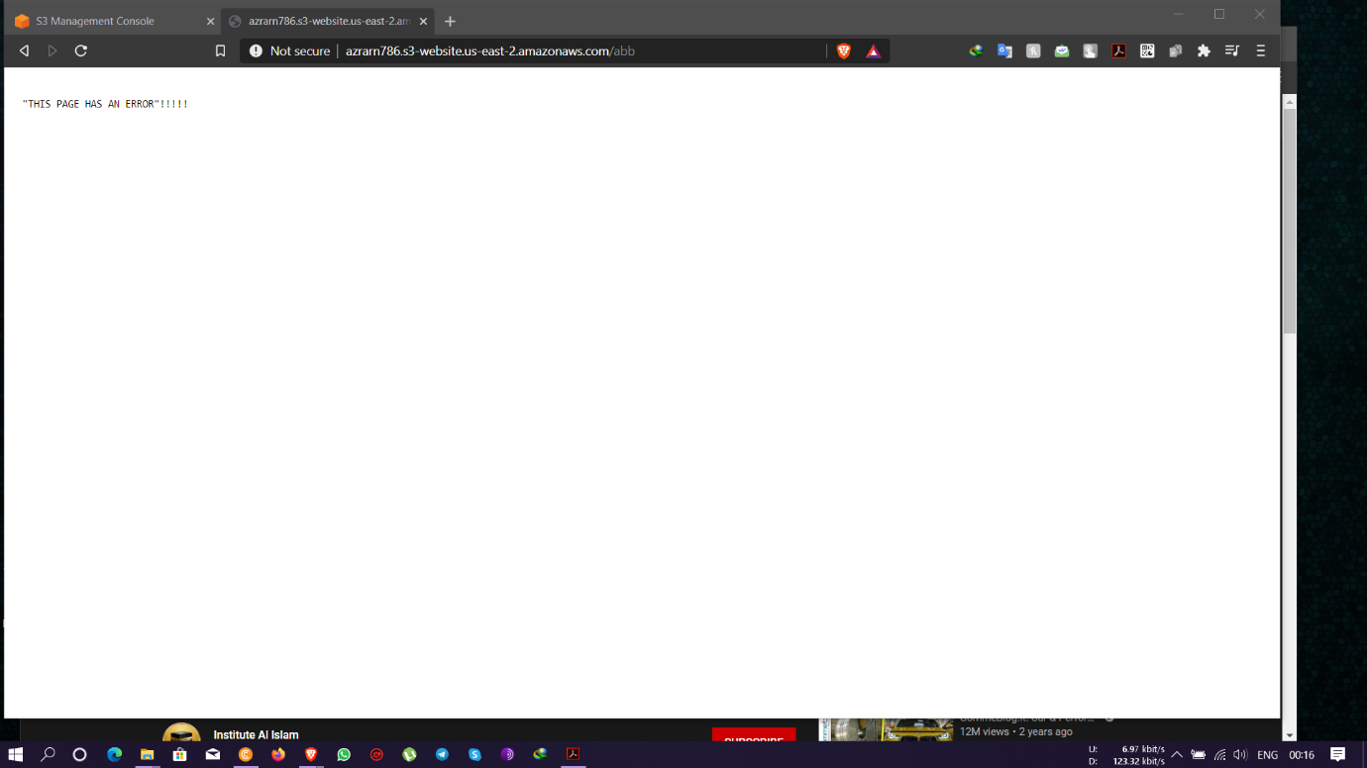

* S3 Versioning enabled

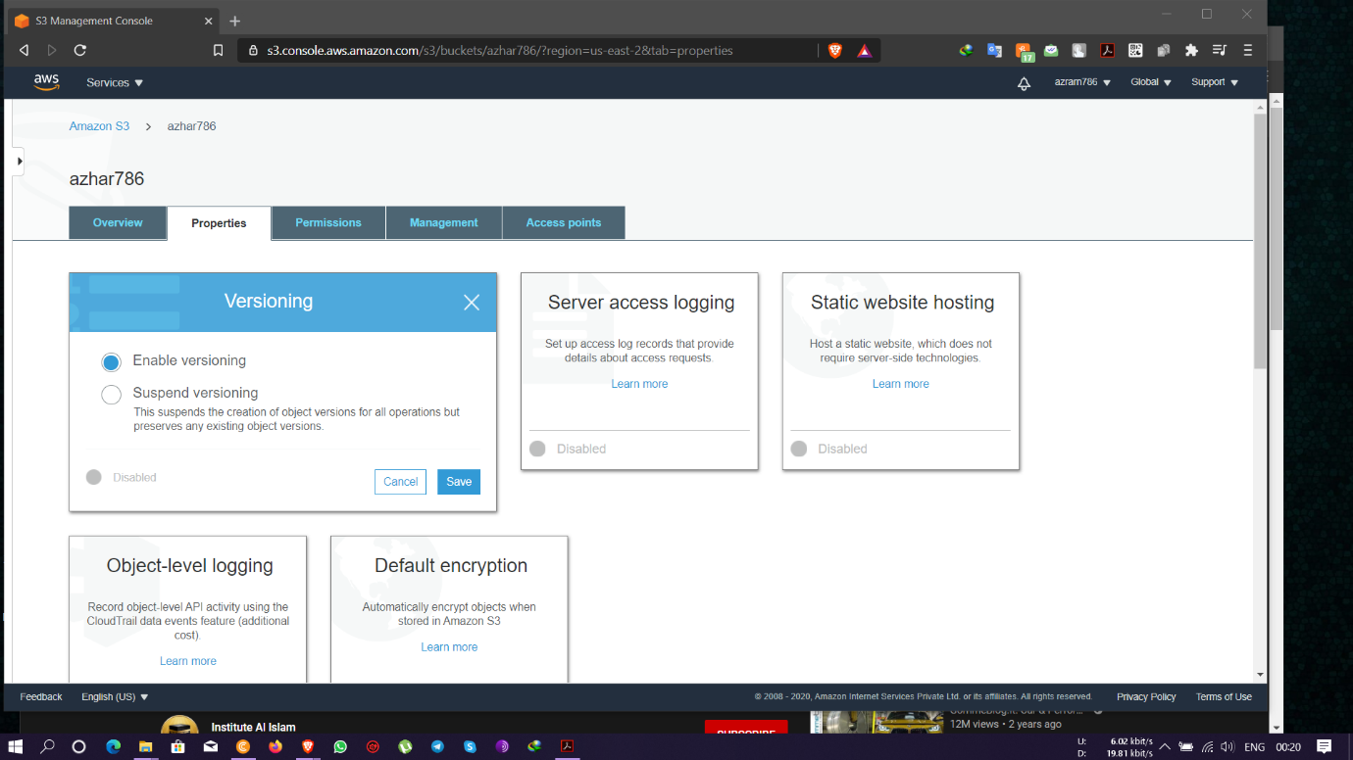

* Files uploaded

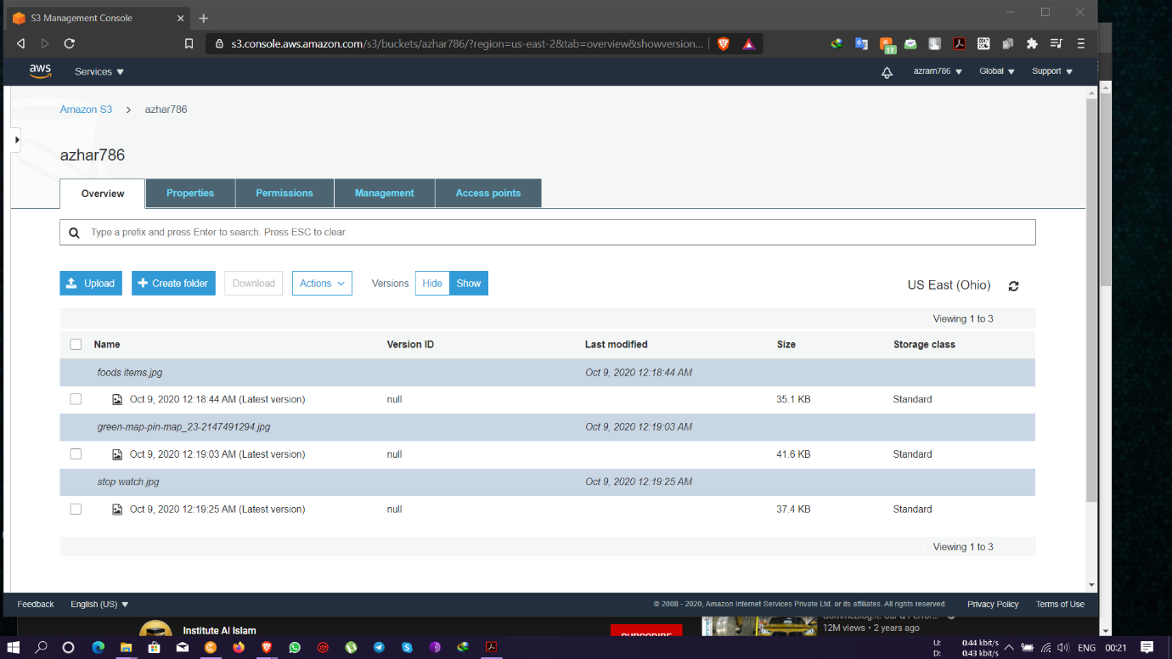

* Files still showing with details after deletion

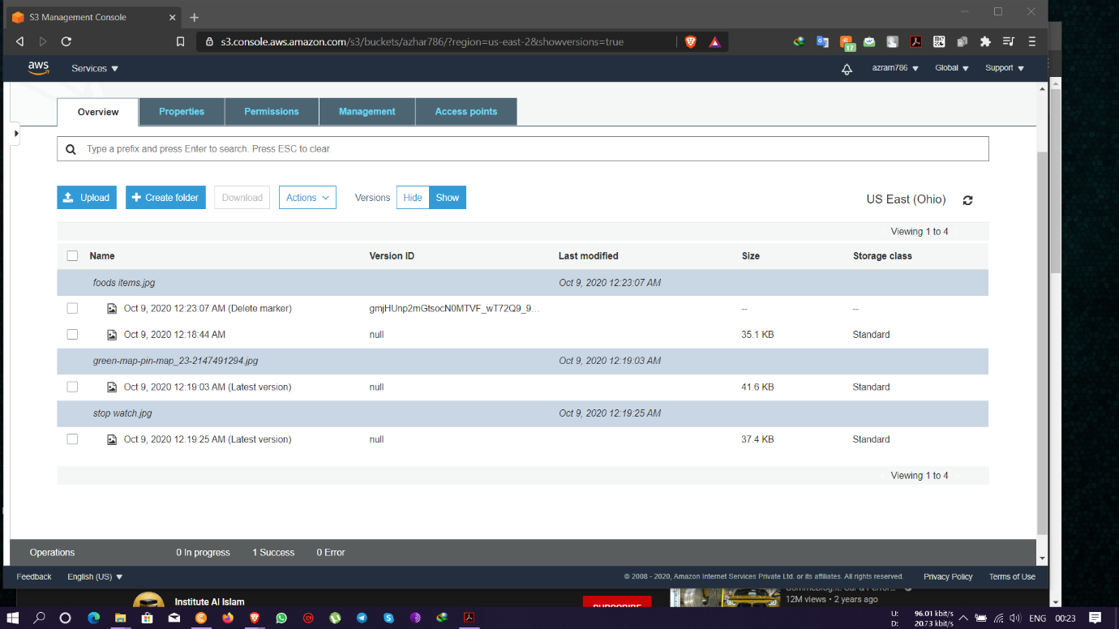

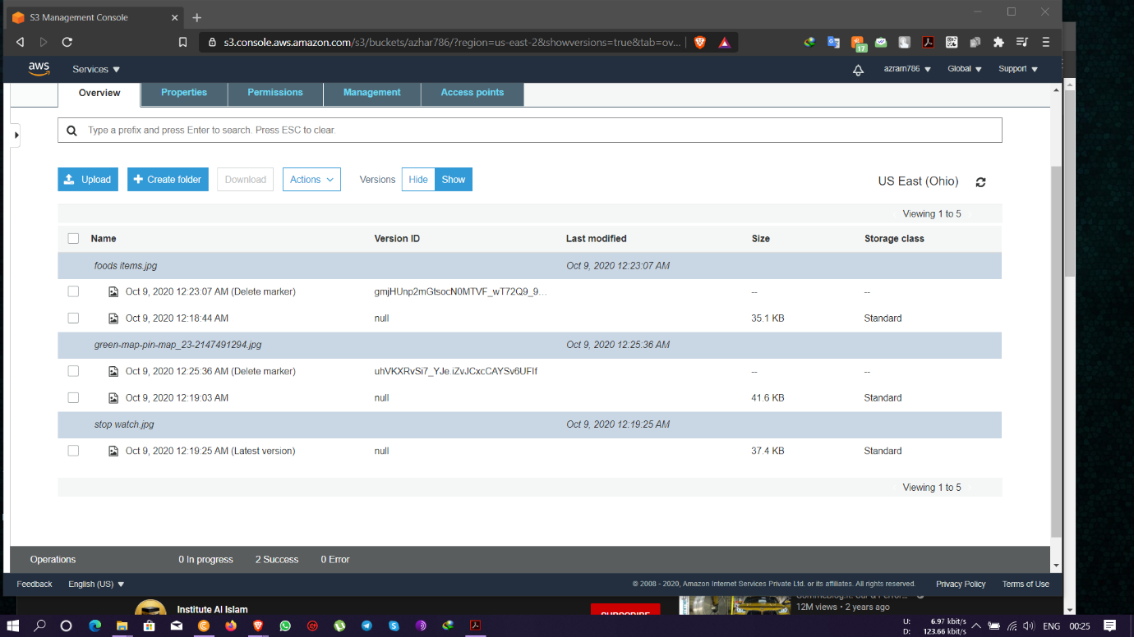

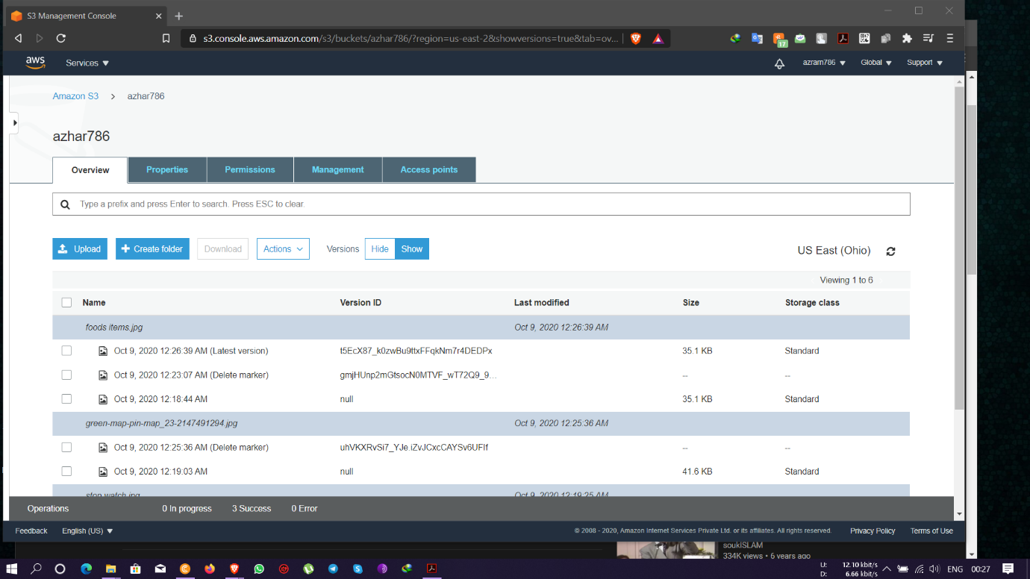

**QUESTION 1:**

Explain life cycle effects on instances: Stop, start, reboot, terminate-public IP, Private Ip, Applications installed.

Answers: -

Stop – Public IP gets released and goes back to the pool, Private IP remains the same and applications too remains installed.

Start – Public IP gets associated with a new IP address for the pool, Private IP remains the same and applications too remains installed.

Reboot – Public IP remains the same, Private IP too remains the same and Applications installed also remains in the installed state.

Terminate – Both Public and Private gets released from the associated ec2 instance and

goes back to the pool and the applications installed gets deleted.